## **How to start Tableau**

The Tableau Public start page is a central location from which you can do the following:

### Connect to your data: Connect to data and open saved data sources.

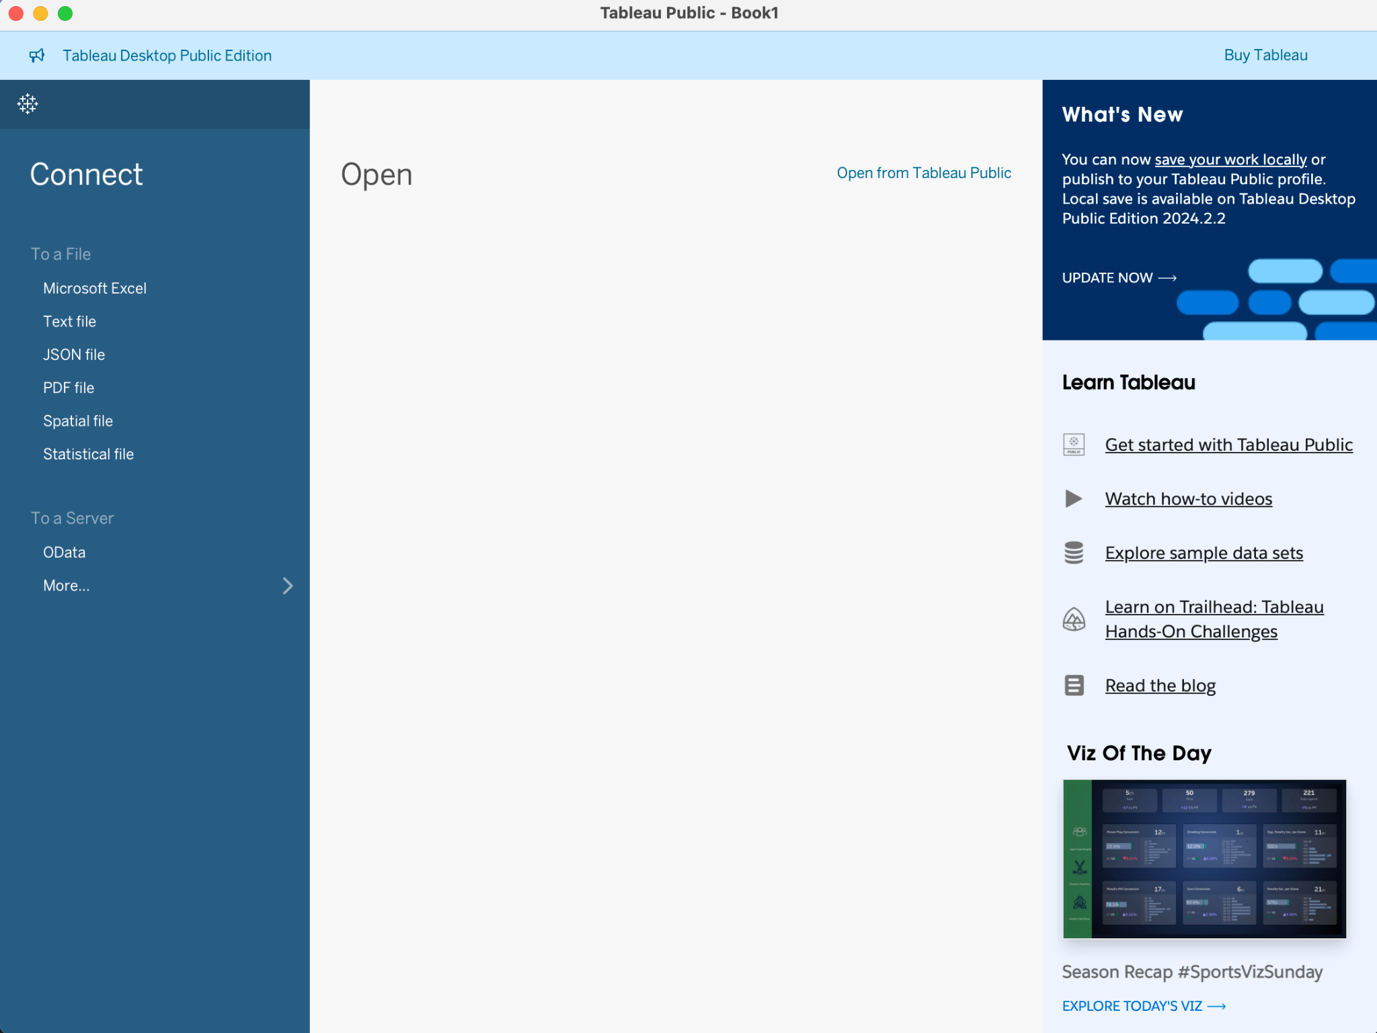

### Explore and learn Tableau



The start page consists of three panes: Connect, Open, and Learn Tableau. Tips: if you do not see the “Learn Tableau” pane, please try to maximize your window.



To access the dataset we'll be using, simply download it from Coursera. If you're interested in other datasets provided by Tableau, click on 'Explore sample data sets.' **Since Tableau frequently updates their datasets, for consistency, please use only the dataset we provide on Coursera for all Tableau assignments.**

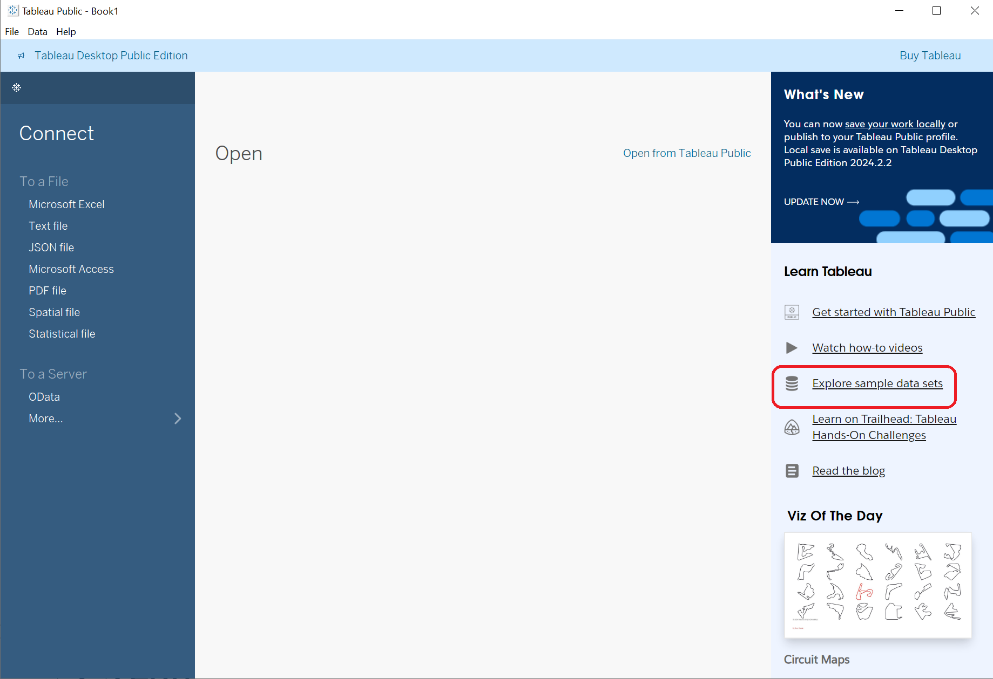

## **How to load data**

* Download “Superstore Sales” dataset from Coursera
* Launch Tableau on your computer
* Click **To a File > Microsoft Excel**
* Load “sample_-_superstore.xls” you just downloaded
* Drag “Orders” to the right side of the window
* Click “Sheet 1”
* Start working on your visualizations

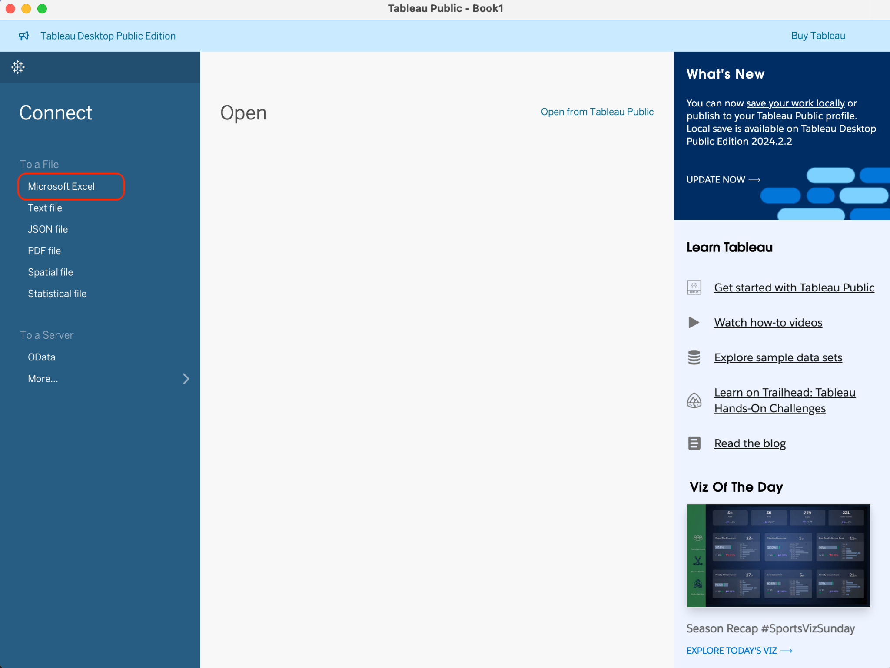

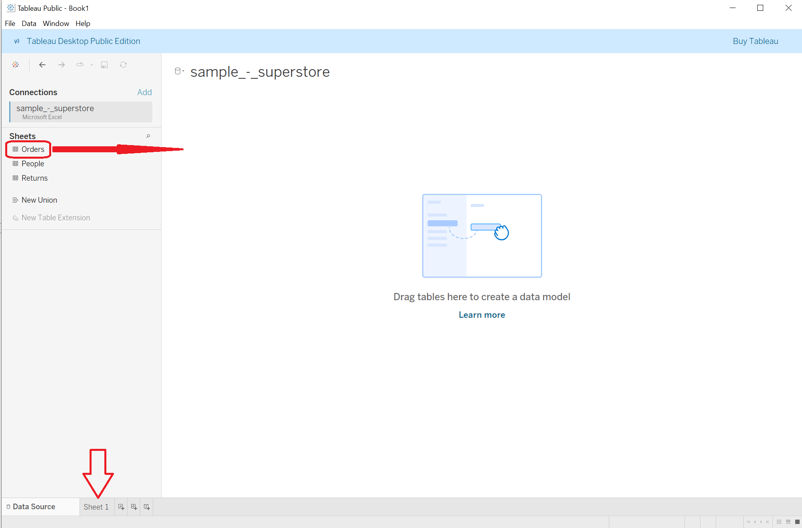

For all the following charts, please connect to **Superstore Sales** data source first.

## **How to build bar charts**

### Set up your chart

* Drag the **Order Date** dimension to **Columns**
* Drag the **Sales** measure to **Rows**.

### Choose your chart type:

* On the Marks card, select **Bar** from the drop-down list.

### Add color and detail:

* Drag the **Ship Mode** dimension to **Color** on the Marks card.
* Drag the **Region** dimension to **Rows**, and drop it to the left of **Sales** to produce multiple axes for sales by region.

### Focus on a Specific Region:

* To view data in the West region only, you can filter out the other regions. To do this, drag the **Region** dimension again, this time from the **Data** pane to the **Filters** shelf.
* In the Filter [Region] dialog box, clear the **Central**, **East**, and **South** check boxes, and then click **OK**.

**Tips**: Bar charts are great for comparing different groups, such as regions in this example.

## **How to build line charts**

### Arrange Your Data:

* Drag the **Order Date** dimension to **Columns**.
* Drag the **Sales** measure to **Rows**.
* Drag the **Profit** measure to **Rows** and drop it to the right of the **Sales** measure.

### Blend Axes:

* Drag the **SUM(Profit)** field from **Rows** to the **Sales** axis to create a blended axis. The two pale green parallel bars indicate that **Profit** and **Sales** will use a blended axis when you release the mouse button.

### Adjust Time Frame: To look at a summation of values on a per-year basis.

* Click the drop-down arrow in the **Year(Order Date)** field on the **Columns** shelf and select **Month** in the lower part of the context menu to see a continuous range of values over the four-year period.

### To forecast feature in the view

* To add a forecast, in the **Analytics** pane, drag the **Forecast** model to the view, and then drop it on **Forecast**.

**Tips**: Line charts show trends over time. Adding profit allows you to compare two different aspects of your data.

## **How to build histogram charts**

### Set up Columns:

* Drag **Quantity** to **Columns**.
* Click **Show Me** on the toolbar, then select the histogram chart type.

### Add color and labels:

* Drag **Segment** to **Color**.
* Hold down the Ctrl key (**Command key on a Mac**) and drag the **CNT(Quantity)** field from the **Rows** shelf to **Label**.

### Adjust table calculations: To make the percentages to be on a per-bar basis

* Right-click (Control-click on a Mac) the **CNT(Quantity)** field on the **Marks** card and select **Quick Table Calculation** > **Percent of Total**.
* Right-click the **CNT(Quantity)** field on the **Marks** card again and select **Edit Table Calculation**.
* In the Table Calculation dialog box, change the value of the Compute Using field to Cell.

**Tips**: Histograms help you understand the distribution of numerical data.

## **How to build pie charts**

### Organize your data:

* Drag the **Sales** measure to **Columns** and drag the **Sub-Category** dimension to **Rows**.

### Select chart type:

* Click **Show Me** on the toolbar, then select the pie chart type. Pie charts require at least one or more dimensions and one or two measures. Aggregate fields, such as Profit Ratio, don't contribute to those requirements.

### Enlarge and label:

* To make the chart bigger, hold down Ctrl + Shift (**hold down Shift + command on a Mac**) and press B several times.
* Add labels by dragging the **Sub-Category** dimension from the **Data** pane to **Label** on the **Marks** card. If you don't see labels, press Ctrl + Shift + B (**press Shift + command + B on a Mac**) to make sure most of the individual labels are visible.

**Tips**: Pie charts are perfect for showing parts of a whole.

## **How to build area charts**

### Prepare your Data:

* From the Data pane, drag **Order Date** to the **Columns** shelf.
* On the Columns shelf, right-click **YEAR(Order Date)** and select **Month**.
* From the Data pane, drag **Quantity** to the **Rows** shelf.

### Add color and style:

* From the Data pane, drag **Ship Mode** to **Color** on the Marks card.
* On the Marks card, click the Mark Type drop-down and select **Area**.

## **How to build Gantt charts**

### Set up dates and categories:

* Drag the **Order Date** dimension to **Columns**. Tableau aggregates the dates by year and creates column headers with labels for the years.
* On the **Columns** shelf, click the **Year (Order Date)** drop-down arrow, and then select **Week Number**.
* Drag the **Sub-Category** and **Ship Mode** dimensions to the **Rows** shelf. Drop **Ship Mode** to the right of **Sub-Category**.

### Create a custom field:

* In the toolbar menu, click **Analysis > Create Calculated Field**. You can also right-click (Control-click on Mac) any field in the **Data** pane and select **Create** > **Calculated Field**.
* In the calculation dialog box, name your calculated field **OrderUntilShip**.

### Adjust for readability:

* Clear any content that's in the **Formula** box by default.
* In the **Formula** box, enter the following formula and then click **OK**:  
  DATEDIFF('day',[Order Date],[Ship Date])  
  The formula creates a custom measure that captures the difference between the **Order Date** and **Ship Date** values, in days.
* Drag the **OrderUntilShip** measure to **Size** on the **Marks** card.  
  The default aggregation for **OrderUntilShip** is **Sum**, but in this case it makes more sense to average the values.
* Right-click (**Control-click on Mac**) the **SUM(OrderUntilShip)** field on the **Marks** card, and then select **Measure (Sum)** > **Average**.
* To make our data more readable by filtering down to a smaller time window.
* Hold down the Ctrl key (**Option key on the Mac**) and drag the **Week(Order Date)** field from the **Columns** shelf to the **Filter** shelf.
* In the Filter Field dialog box, select **Range of Dates** and then click **Next**.
* Set the range to a three-month time interval, such as 1/1/2017 to 3/31/2017, and then click **OK**.
* Drag the **Ship Mode** dimension to **Color** on the **Marks** card.

**Tips**: Gantt charts are useful for showing the duration of events or activities.

## **How to build scatter plots**

### Position your data

* Drag the **Profit** measure to **Columns**.
* Drag the **Sales** measure to **Rows**.

### Add detail and color

* Drag the **Category** dimension to **Color** on the Marks card.
* Drag the **Region** dimension to **Detail** on the **Marks** card.

### Incorporate trend lines

* To add trend lines, from the **Analytics** pane, drag the **Trend Line** model to the view, and then drop it on the model type.
* Hover the cursor over the trend lines to see statistical information about the model that was used to create the line.

**Tips**: Scatter plots are great for spotting correlations between two variables.

For all the following charts, please connect to the **All Flights (flightpaths)** data source first.

Spatial Visualizations Using **MAKELINE** and **BUFFER:** You first need to load spatial data. For this example, we will use the 'All Flights (flightpaths)' dataset (You can find it on Coursera).

### How to load the saved dataset

1. Click **File** > **Open**

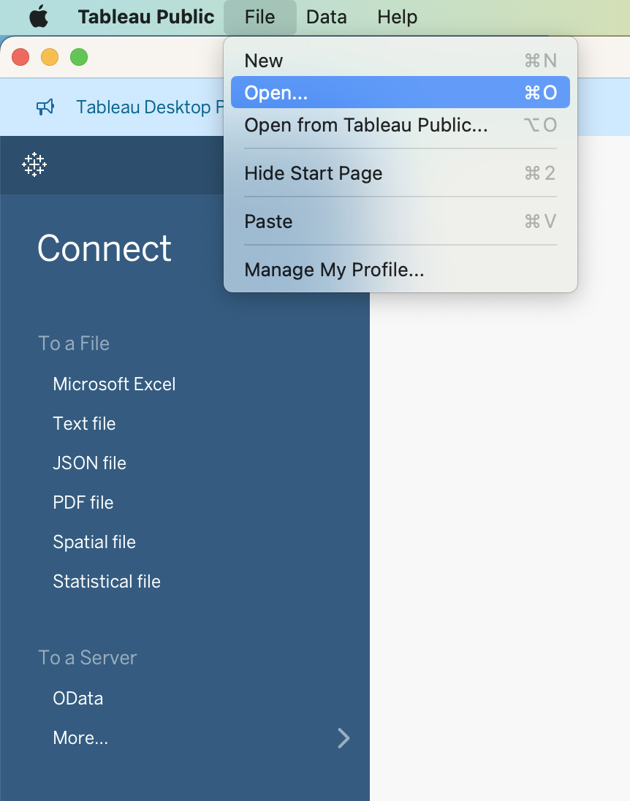

1. Select the workbook you want to load:

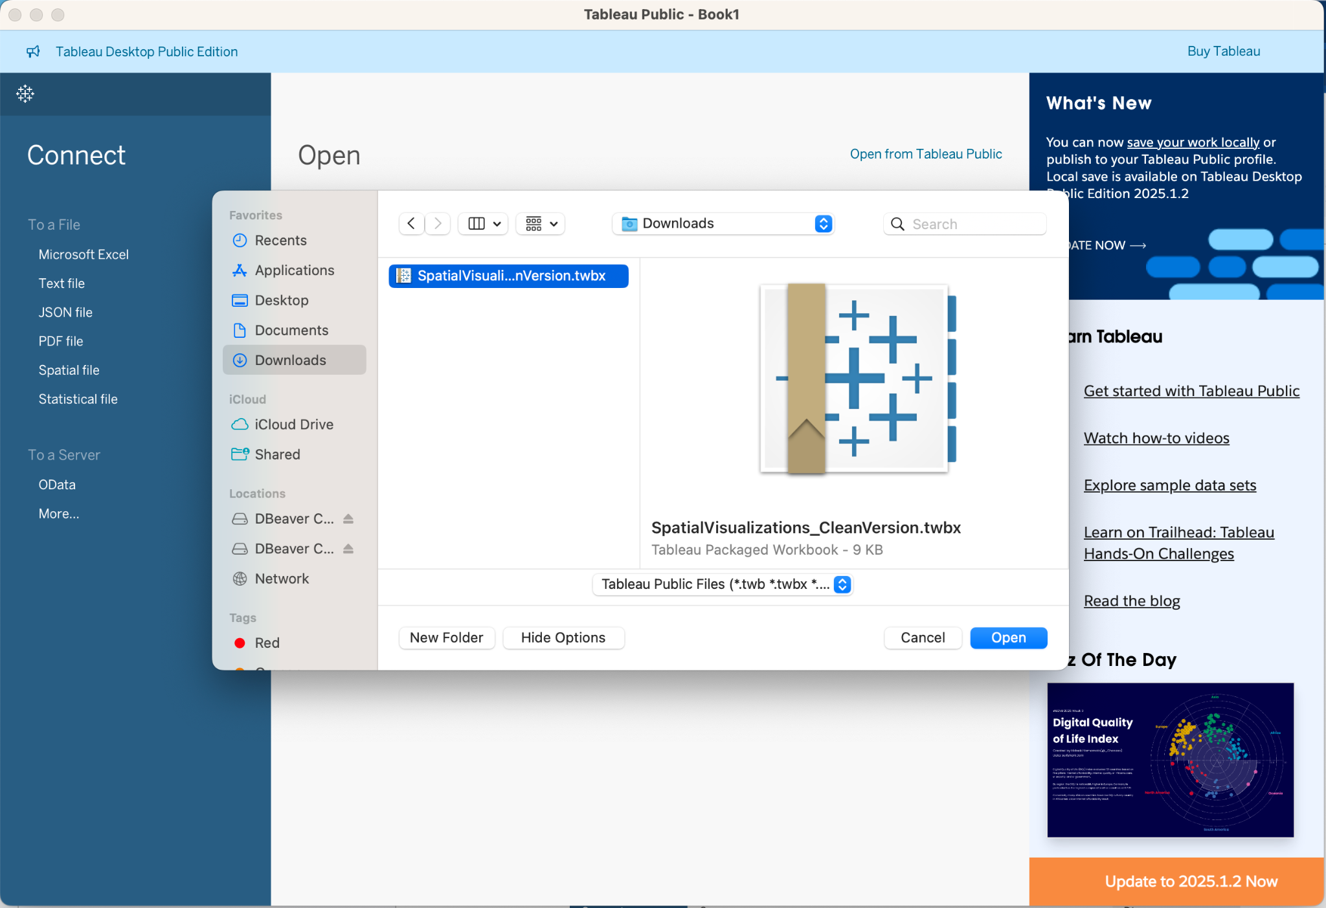

1. Click Open
2. After selecting the data source, it will be loaded into Tableau, and you will be taken to the data source page where you can view and prepare your data before analyzing it.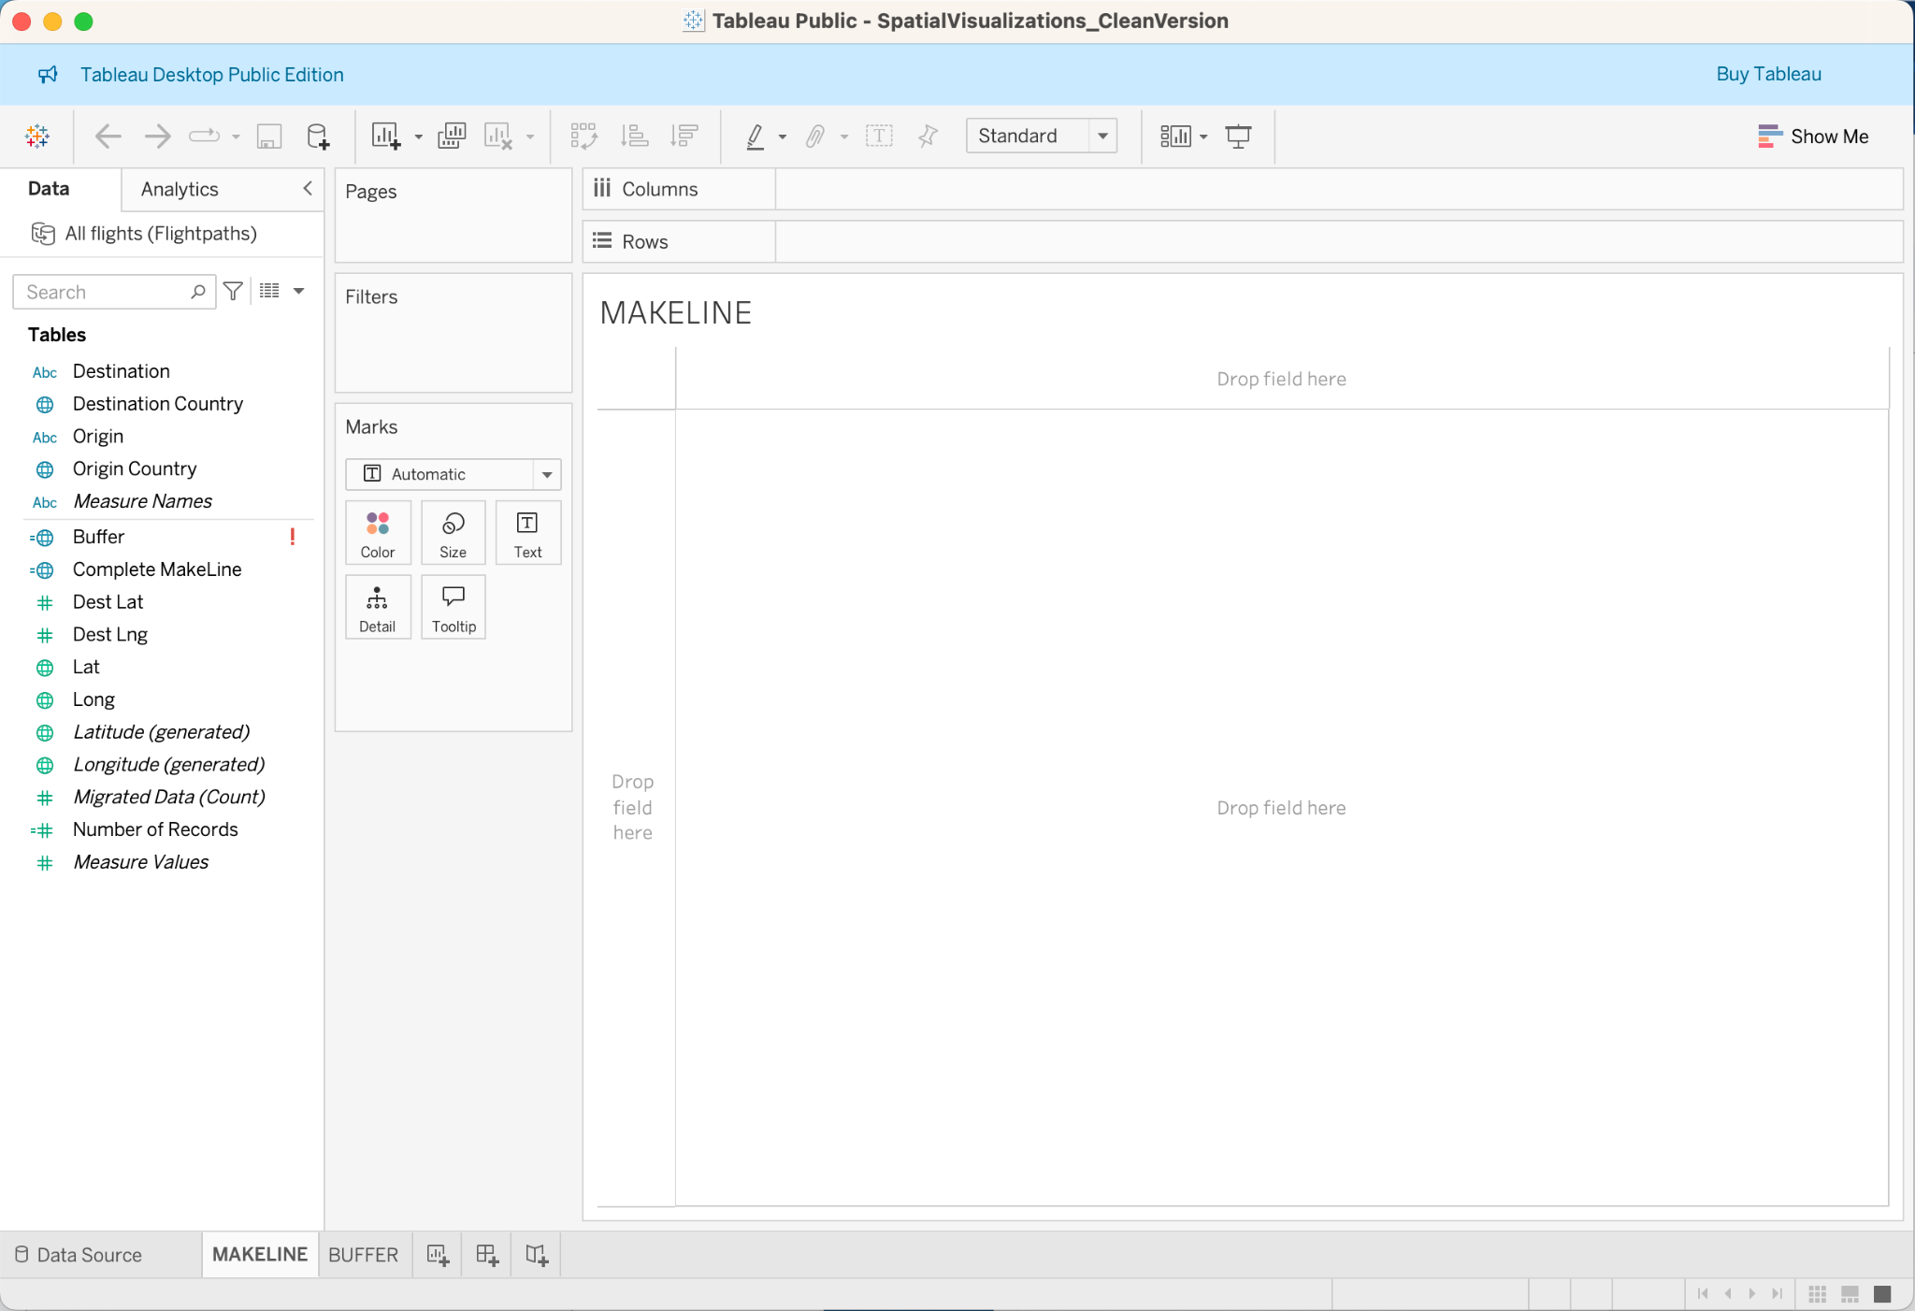

### **How to create a visualization using MAKELINE**

1. Navigate to a MAKELINE worksheet.
2. Select Analysis > Create Calculated Field.
3. In the calculation that opens, do the following:

* Name the calculated field Flight Paths
* Enter the following formula: MAKELINE(MAKEPOINT([Lat],[Long]),MAKEPOINT([Dest Lat],[Dest Lng]))

This formula takes latitude and longitude coordinates from your origin and destination cities and turns them into geographic points for spatial analysis. Those coordinates are used to build to two-point lines between origin and destination.

1. When finished, click OK.
2. From the Data pane, double-click Flight Paths to add it to your visualization, which should automatically render as a map.

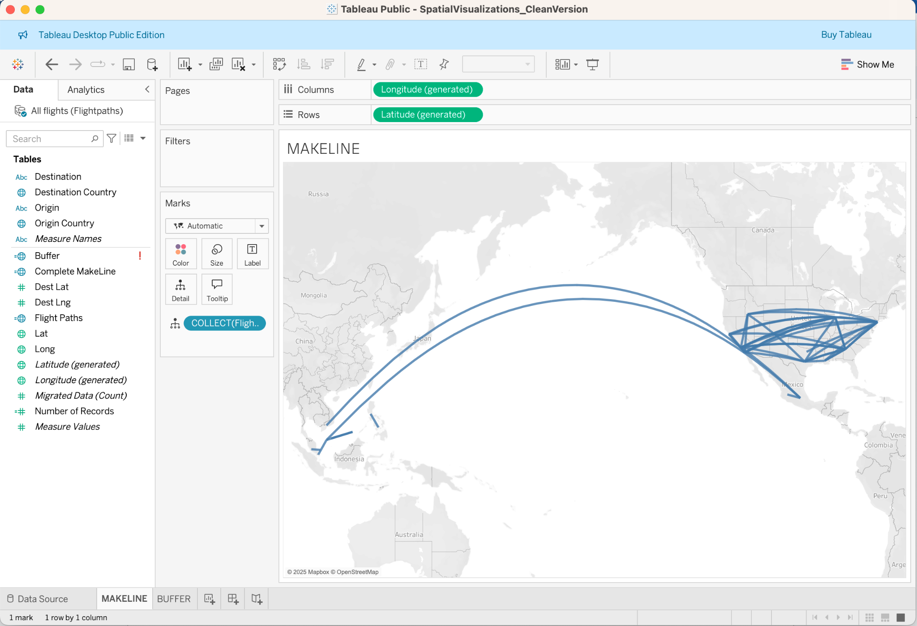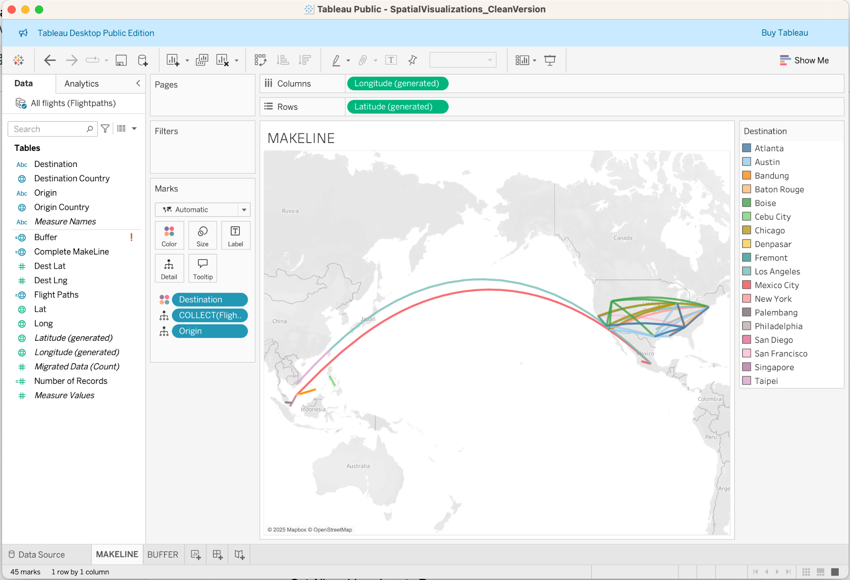

### **How to create a visualization using BUFFER**

1. Navigate to a BUFFER worksheet.
2. Right-click the Data pane and select Create **Parameter**.
3. In the Parameter dialog that opens, set the options below:

* Name the parameter Buffer Distance
* Set the Data Type to Integer
* Set Allowable values to Range
* Set the Minimum range to 100, the Maximum range to 1000, and the step size to 100.

1. When finished, click OK.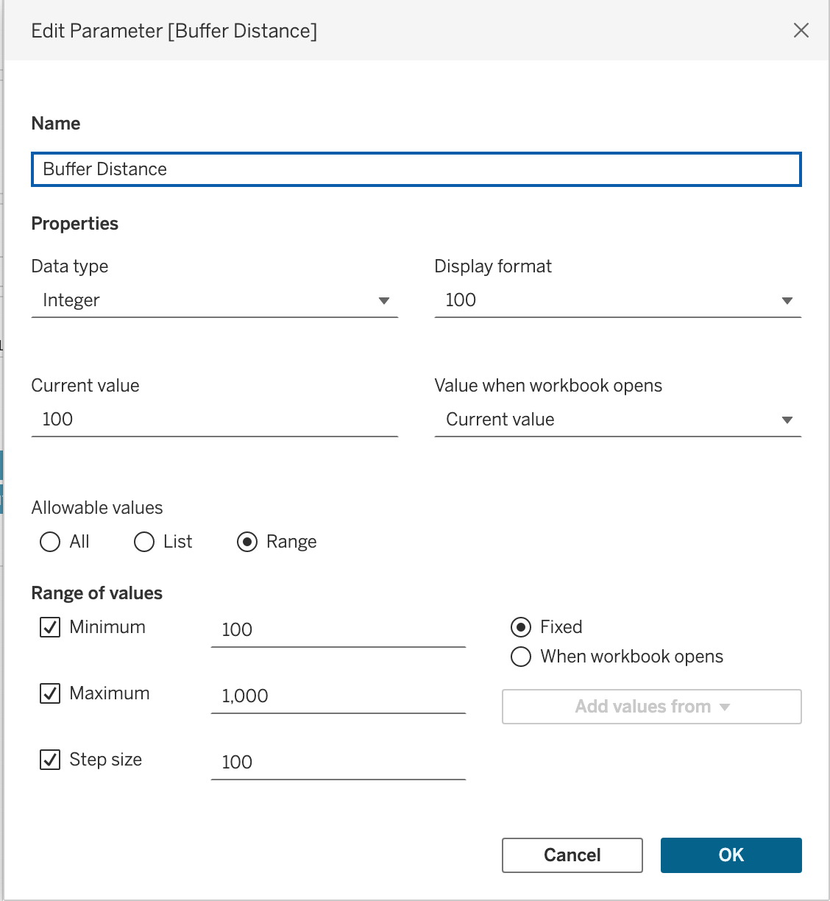
2. Select Analysis > Create Calculated Field.
3. In the calculation that opens, do the following:

* Name the calculated field Buffer
* Enter the following formula:

BUFFER(MAKEPOINT([Dest Lat],[Dest Lng]),[Buffer Distance],"miles")

1. When finished, click OK.
2. From the Data pane, double-click Buffer to add it to your visualization, which should automatically render as a map.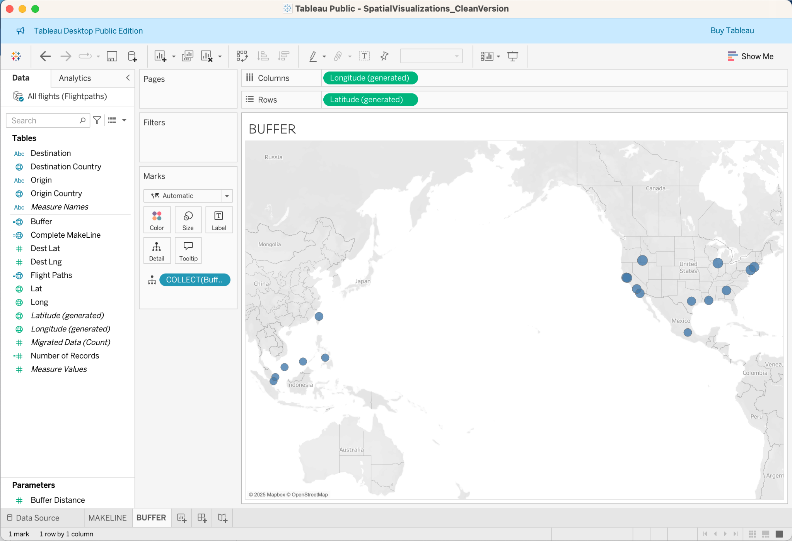
3. Drag Destination to the Color panel on the Marks card to complete the visualization.

